
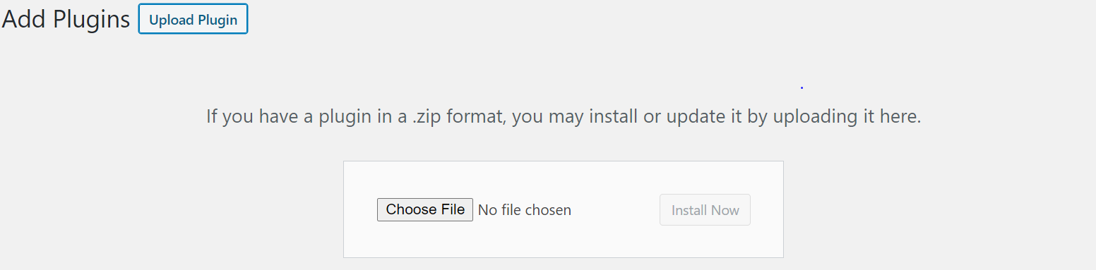
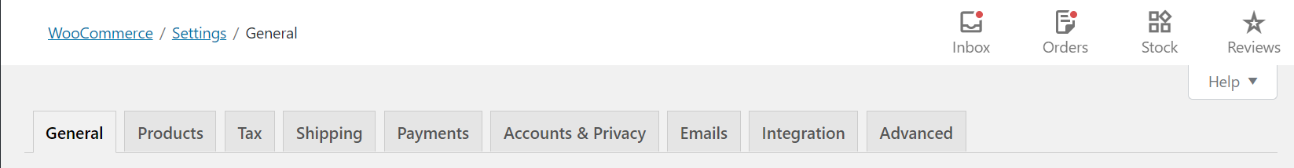
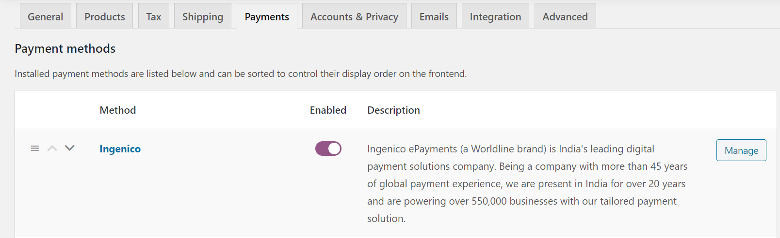
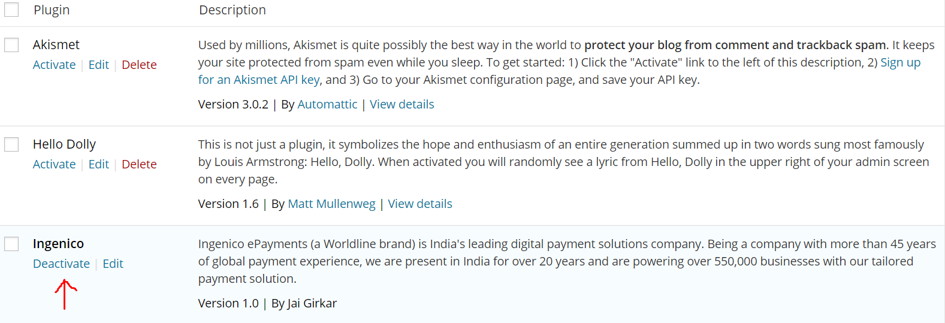
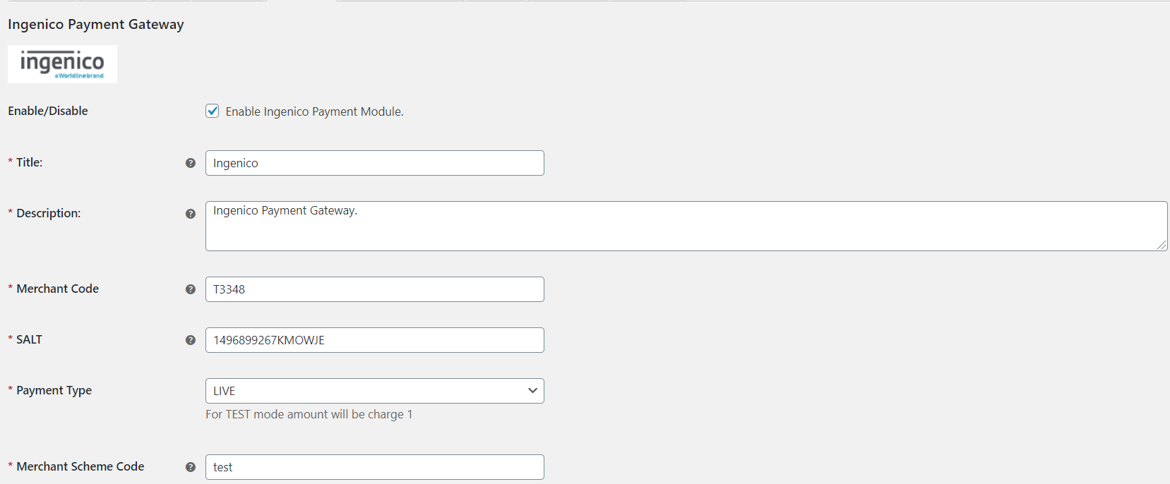
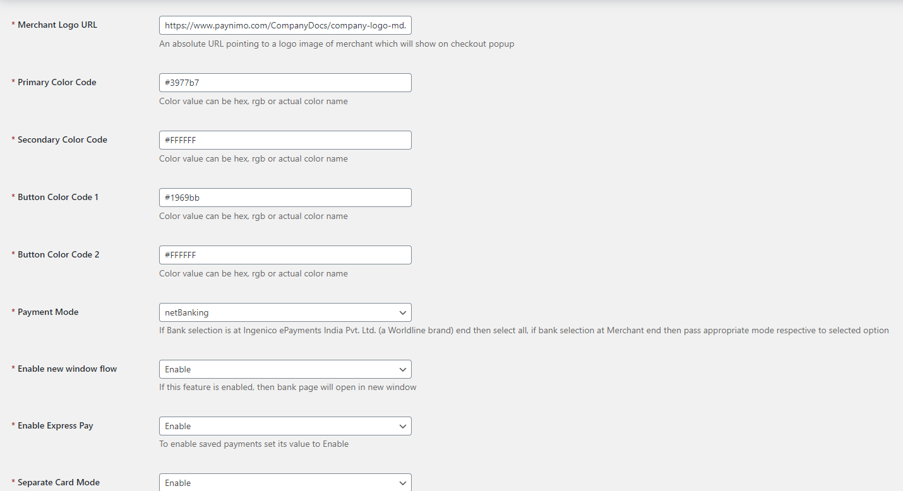
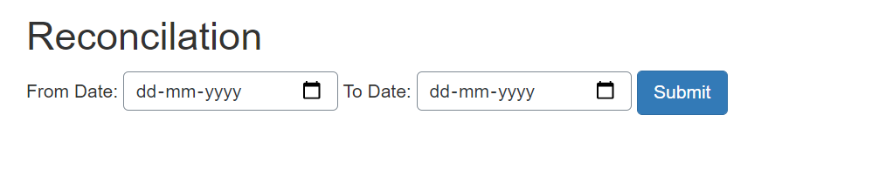
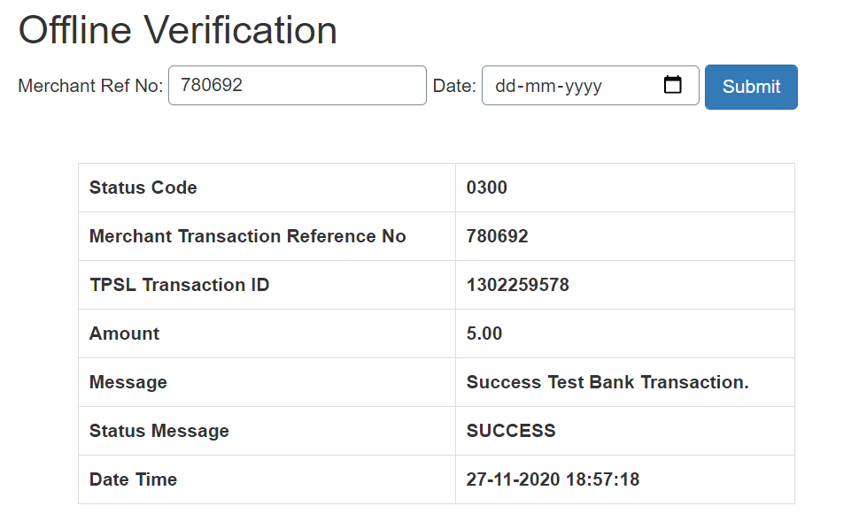
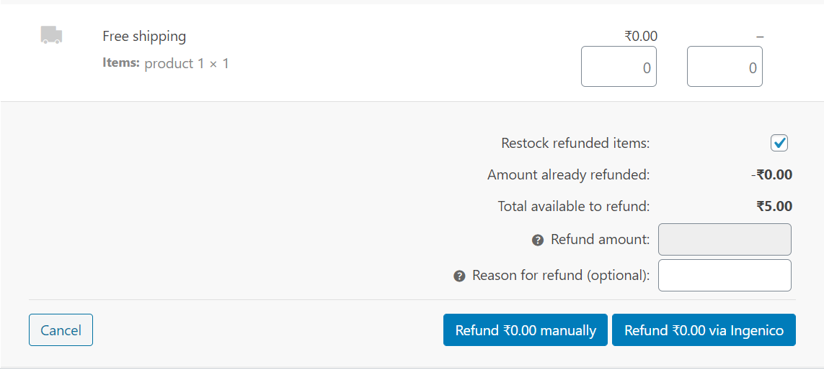



INSTALLATION MANUAL

Table of Contents

Applicable Version………………..…....……………………………….……………………….1

Installation....………………………….……….……………………………………………………1

Configuring worldline………………..……………………………………………………………3

Applicable versions

Applications | Versions
PHP | 5.6.x to 7.2.x
Wordpress | 4.5.x to 5.0.0
Woocommerce | 3.x to 3.9.x

Installation & Upgrade

Please follow the given steps to install and run the worldline Payment Gateway module

1. Login to site admin in wordpress site
2. After successful login, we will find a menu bar at the left side of the corner. Go to Plugins menu select ‘Add New’ option.
3. Click the ‘Upload Plugin’ button.
4. Browse the provided zip folder and click on the ‘Install Now’ button.

5. After successful install click on ‘Activate Plugin’ link.
6. Click on WooCommerce>setting link.

7. Click on Checkout/Payments page tab and then select worldline option from ‘Payments Options’.
8. Click on worldline and Manage Payment Gateway Settings.

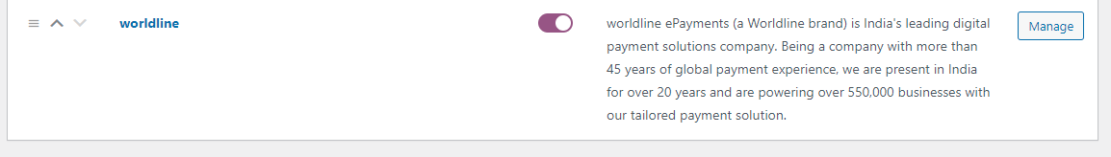

Update Plugin

- Go to the ‘Plugins’ in the left admin Menu select the worldline Plugin and Click in Deactivate.

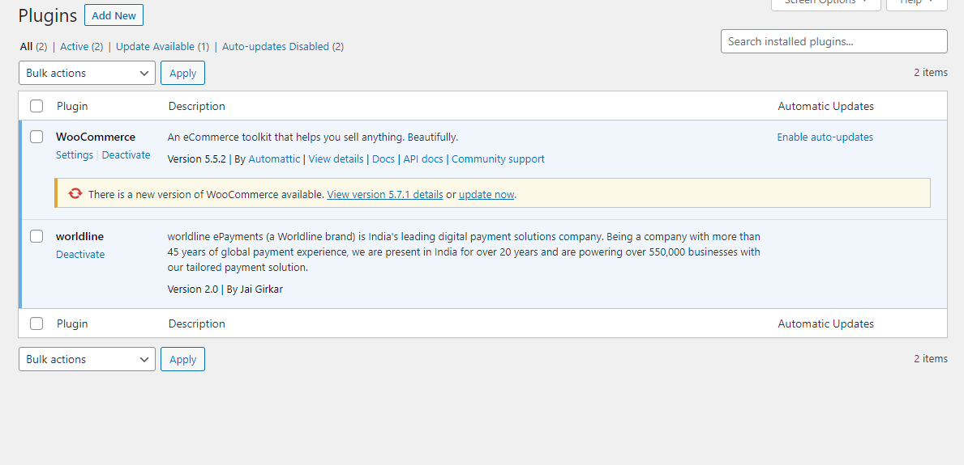

- After Deactivation ‘Delete’ the plugin and Upload the new plugin->Install->Activate.

Configuring worldline

- Go-to admin panel.
- Scroll down. You will get following fields:
- Configure it as below:
Column Name | Description
Enabled | Click on the checkbox in order to Enable worldline
Merchant Code | Enter Merchant Code
Salt | Enter Salt.
Payment Type | For Test mode Select ‘Test’ and for Live mode select ‘Live’
Merchant Scheme Code | Enter Scheme Code
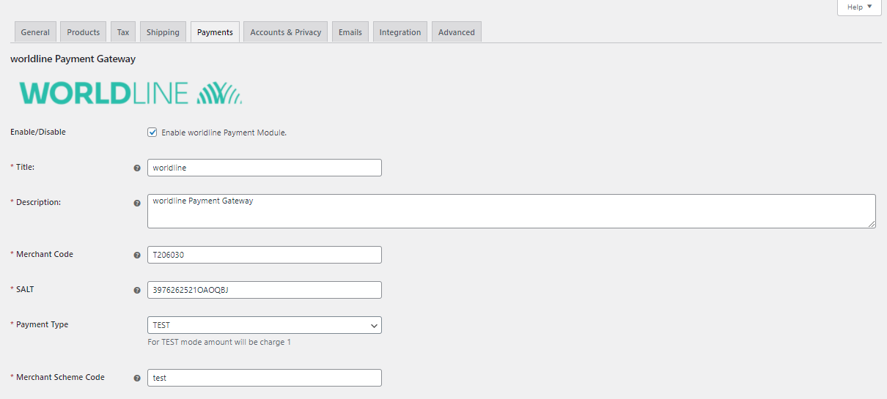

- Now click on “Save Changes” on the bottom-left corner.
- worldline Payment Gateway is now configured & ready to use.

Advanced Configuration

There are also some advanced configuration options you may consider as shown below:

Features List

Dual verification of response:
We are validating responses with a hash value and call again Payment Gateway for dual verification from the payment gateway before updating to the order status.

Reconciliation

Merchants can update the pending status of the order automatically if the payments are successful. This page can be found under Left Admin menu > Reconciliation

Logs request and response

Daily new file creates for the logs request and response from the server for future reference.

S2S Verification
If we do not receive any response from the payment gateway then after 30 mins, we will get a response from the server and based on the response it will update order status.
To configure S2S URL, contact prod team.

S2S url format : hostname/wp-json/worldline/s2sverification
S2S url example : http://example.com/wp-json/worldline/s2sverification

MCG
It supports the multi currency like USD, GBP, SGD and a lot more.

worldline Offline Verification

Merchants can verify the status of their payment by using the Payment Verification page. The payment verification page can be found under Left Admin menu > worldline Offline Verification

Refund

Merchants should be able to process the refund online for the order whose payment has been done via worldline.

To refund an order select the particular order you want to refund and click on Refund > Refund via worldline.

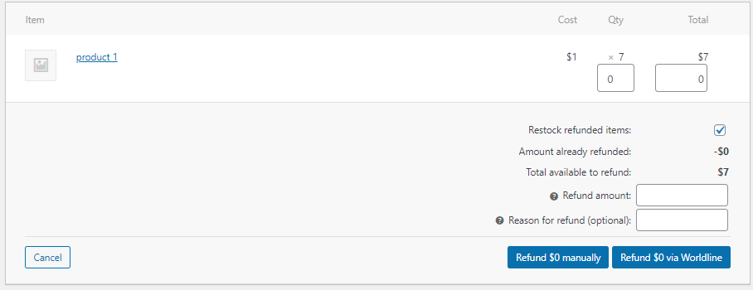

Embed Payment Gateway

After enabling this setting, payment gateway displays like embedded on the page instead of pop-up so user experience would be good.

Documentation link
https://www.tecprocesssolution.com/proto/p2m/client/salt-based-documentation.htm#online

